Original Article
Title of the article: If your final manuscript has 15 pages or more [Georgia 18]
Author A^{1*}, Author B^{1*}, Author C¹ and Author D² [Georgia 10]
1Departement, Faculty, Institution, City, Country [Georgia 8];
2Departement, Faculty, Institution, City, Country [Georgia 8];

*Corresponding author: authoremail@email.com

Abstract
A concise non-structured abstract is required. The abstract should state briefly the purpose of the research, the principal results and major conclusions. Abstract must be able to stand alone. References should be avoided. Non-standard or uncommon abbreviations should be avoided, but if essential they must be defined at their first mention in the abstract itself. Five key words should be listed after the abstract. Keywords should be self-sufficient to allow the classification of the paper by subject area and to function as heads in a volume’s index of keywords. Choose them according to Index Medicus, do not merely duplicate words from the title.
Keywords: Keyword 1, keyword 2, keyword 3, keyword 4, keyword 5 [Georgia 9]

Introduction
The introduction section sets the stage for your study by providing context, defining the problem, highlighting its significance, and outlining your contribution. It should engage the reader, establish the relevance of your work, and clearly articulate the objectives of the research.
The introduction establishes the foundation for your entire paper and should engage the reader while clearly establishing the context and purpose of your research [1]. When writing your introduction [2], address these key questions: What is the background and context of this research? What previous work has been done in this area? (Provide a brief literature review), What gap or problem does your study address? Why is this research needed? What are your specific research objectives or questions?
Begin with broader concepts and gradually narrow to your specific research focus. The introduction typically comprises 1-1,5 pages and should include context and background, problem statement, significance of the problem, literature review (brief), research objective, and contributions [3].

Methods
The methods section provides a detailed, clear, and reproducible description of how you designed, implemented, and evaluated your model. The methods section should provide sufficient detail to allow other researchers to reproduce your work [4], [5].
Describe your research methodology clearly and systematically [6]. Key components of the methods section: Provide a high-level summary of your proposed method or model, including its key innovation or contribution. Specify the dataset(s) used for training, validation, and testing. Describe the structure of your model in detail. Use diagrams or equations where appropriate to clarify complex architectures. List the metrics used to assess model performance. Include diagrams, flowcharts, or tables to illustrate the model architecture or experimental setup.
Avoid presenting general scientific concepts or general definitions in the manuscript.

Manuscript length and Equations
The APPS articles should be 6-10 pages for research article and 10-12 for review article, including references [7-8]. Extra pages will incur additional charges.
Equations should be numbered sequentially in parentheses. Equations are written using equation editors with index numbers such as equations 1.
$∆F= -2,3 x {10}^{6} x F^{2}\frac{∆M}{A}$ (1)
Each variable in the equations must be explained in the form of sentences as above. Avoid writing equations captions in item-list form. The program listing is not allowed, please write in the form of pseudocode or algorithm or flow chart.

Manuscript Organization, Title and Author
The manuscript content should be organized in the following order: Title; Authors Name; Authors Affiliation; Abstract; Keywords; Introduction; Methods; Results and Discussions; Conclusions; Acknowledgments; and References. The structure of this journal follows a standard format and should not be modified or condensed, except for the use of subheadings. Each subheading must contain more than one paragraph; no subheading should consist of a single paragraph.
The title manuscript should be clear, simple, concise, and informative, describe the content of the article, contain a maximum of 12 words, use a font size of 18pt, not be bold, and only the first letter of the word should be capitalized. The minimum title contains the result, problem, and method.
The author's name is written without the title. If the corresponding author is not the first author, then the symbol * can be added after the corresponding author's name. The name of the affiliation (department, faculty, institution) does not need to be translated into English.

Table
Tables are numbered consecutively (Table 1, Table 2, etc.) with the title at the top center. Tables must be original or properly cited, and mentioned in the manuscript (e.g., "as shown in Table 1").
The table should also be in its actual format, not some other format, such as an image. There is no vertical line in the table. If required, the table can also be formatted with one column.
Table 1. Table title
Sample | Value ((± SD) | p-value
ABC | 2,375 ± 3.25 | 0.123^{a,}*
DEF | 2,375 ± 3.25 | 0.123^{b}
GHI | 2,375 ± 3.25 | 0.123ª
JKL | 2,375 ± 3.25 | 0.123^{b,}*

Figure
Figures are numbered in order of appearance (Figure 1, etc.) with captions centered below. Use high-resolution images (minimum 300 dpi), explained, and referenced. cite all figures in the text (e.g., "as illustrated in Figure 1"). Authors may use one column for figures and avoid blank spaces.
Ensure that figures are clear and legible with typed letterings. Black & white or colored figures are allowed. If a figure spans two columns, it should be placed at the top or bottom of a page.
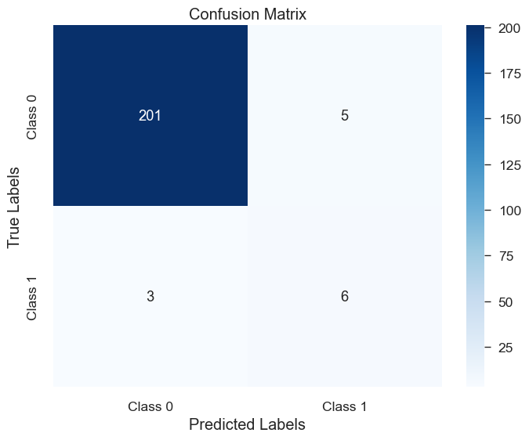
Figure 1. Confusion Matrix

Results and Discussions
The results and discussion section presents your findings and interprets their significance [11]. This section forms the core of your paper and should directly address your research questions [12]. Organize your results logically, moving from major to minor findings, or chronologically if appropriate.
When presenting results: Use tables and figures to display complex data efficiently. Describe patterns, trends, and key observations in the data. Compare your findings with previous research. Explain unexpected or contradictory results. Discuss the implications of your findings for theory and practice. Address limitations of your study. Suggest directions for future research.

Key Finding 1
Present and interpret your first major result. Explain its significance and how it relates to your research questions. Compare with existing literature and discuss implications.
Manuscript is written on A4 size paper ((210mm x 297mm), The margin is 25 mm from top to bottom, left and right. Two columns with a column spacing of 0.4pt are displayed.

Key Finding 2
Follow similar approach for your second major finding. An effective way to create a well-structured manuscript is to follow this guide directly. When presenting content, it is recommended to avoid using numbered formats (e.g., 1, 2, 3, a, b, etc.) and instead express ideas in full sentence form (paragraph). Refrain from using bulleted or symbol-based lists (such as *, •, and similar). Additionally, avoid leaving blank areas on the page to maintain a consistent and professional layout .

Limitations and Future Work
Acknowledge constraints in your methodology or findings and suggest how future research might address these limitations. Throughout this section, maintain objectivity and ensure your interpretations are supported by your data. Avoid overgeneralizing or making claims beyond what your results can support.
Limitations refer to the constraints, weaknesses, or shortcomings of the research that may affect the generalizability, validity, or reliability of the results. Future work refers to recommendations for further research based on the findings, gaps, or limitations of the current study. It outlines areas where additional investigation could be valuable or necessary.

Conclusion
The conclusion section summarizes the key findings, highlights the significance of the work, and provides a concise closure to the study. It should be succinct, avoid introducing new information, and reinforce the contributions of your research while pointing to future directions.
The conclusion synthesizes your key findings and articulates their broader significance. This section should: Summarize the main results without introducing new data. Directly address how your findings answer your research questions. Highlight the original contribution your work makes to the field. Discuss practical applications or theoretical implications.
We strongly recommend that you write your conclusion in one paragraph (not in bullet points) and keep it to around 250-350 words.
Acknowledgments
Acknowledgements should be placed at the end of the article before the references. List here those individuals who provided help during the research such as providing language help, writing assistance or proof reading the article and others.

References (Minimum 25 ref from reputable journal with DOI link)
1. A. Amobonye, J. Lalung, G. Mheta, and S. Pillai, “Writing a Scientific Review Article: Comprehensive Insights for Beginners,” The Scientific World Journal, vol. 2024, pp. 1–13, Jan. 2024, doi: 10.1155/2024/7822269.
2. S. Nundy, A. Kakar, and Z. A. Bhutta, “How to Write the Introduction to a Scientific Paper?,” in How to Practice Academic Medicine and Publish from Developing Countries?, Singapore: Springer Nature Singapore, 2022, pp. 193–199. doi: 10.1007/978-981-16-5248-6_17
3. C. Busse and E. August, “How to Write and Publish a Research Paper for a Peer-Reviewed Journal,” Journal of Cancer Education, vol. 36, no. 5, pp. 909–913, Oct. 2021, doi: 10.1007/s13187-020-01751-z.
4. L. F. Azevedo, F. Canário-Almeida, J. Almeida Fonseca, A. Costa-Pereira, J. C. Winck, and V. Hespanhol, “How to write a scientific paper—Writing the methods section,” Rev Port Pneumol, vol. 17, no. 5, pp. 232–238, Sep. 2011, doi: 10.1016/j.rppneu.2011.06.014.
5. S. K. Arora and D. Shah, “Writing methods: How to write what you did?,” Indian Pediatr, vol. 53, no. 4, pp. 335–340, Apr. 2016, doi: 10.1007/s13312-016-0847-7.

